## STUDENT NAME: ***Yash Gupta***

## UID: ***20BCS5009***

## SECTION/GROUP: ***CSE 34/B***

# ***2nd Experiment***

# SUBJECT: DIGITAL ELECTRONICS

# DATE OF PERFORMANCE: 15 SEPTEMBER, 2020

# AIM:

(a)       Design a burglar alarm (AND).

(b)       Design a single doorbell ringer for both front and back doors (OR).

(c)       Design an automatic fan controller (NOT).

# Task to be done:

We will solve some day to day problems with basic logic gate.

# Requirements:

7404 (NOT) IC, 7408 (AND) IC, 7432 (OR) IC, 5V Power Supply, Breadboard, Connecting wires, Simulation software, Windows 10 PC.

# Circuit diagram/ Block diagram:

#### Burglar Alarm using AND gate.

#### 

**(b)    Single doorbell ringer for both front and back doors, using OR gate.**

#### 

**(c)       Design an automatic fan controller (NOT).**

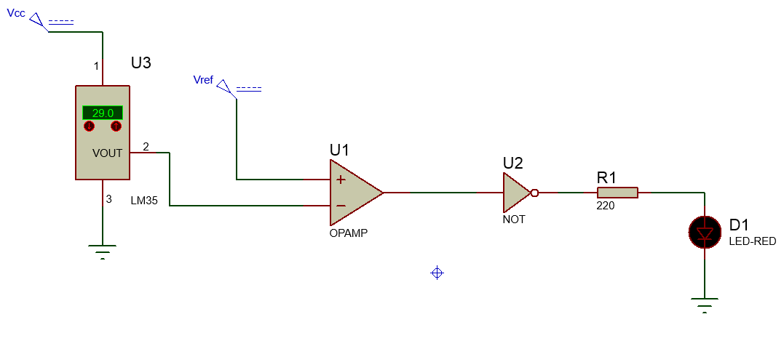

* **Simulation Results:**

1. **Door Bell (When both switches are off.**)

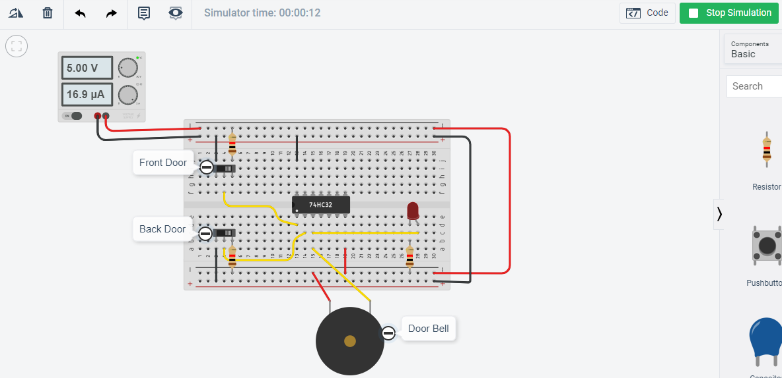

**Door Bell (When one switch is on & another is off.**)

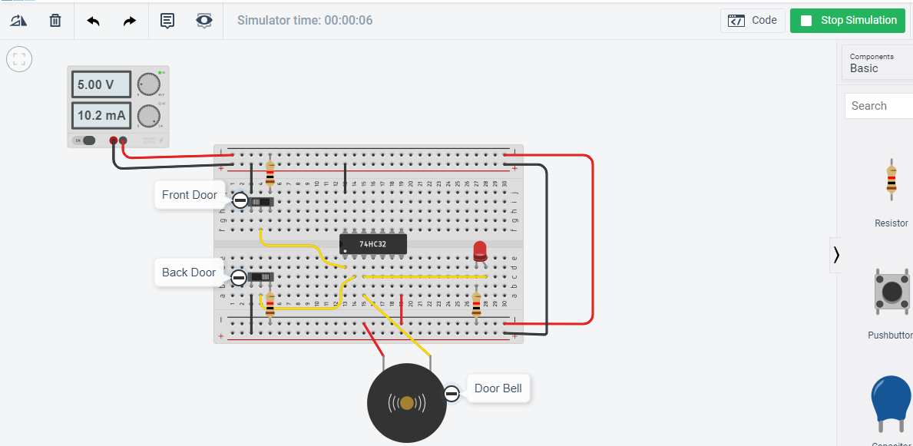

**Door Bell (When both switches are on.**)

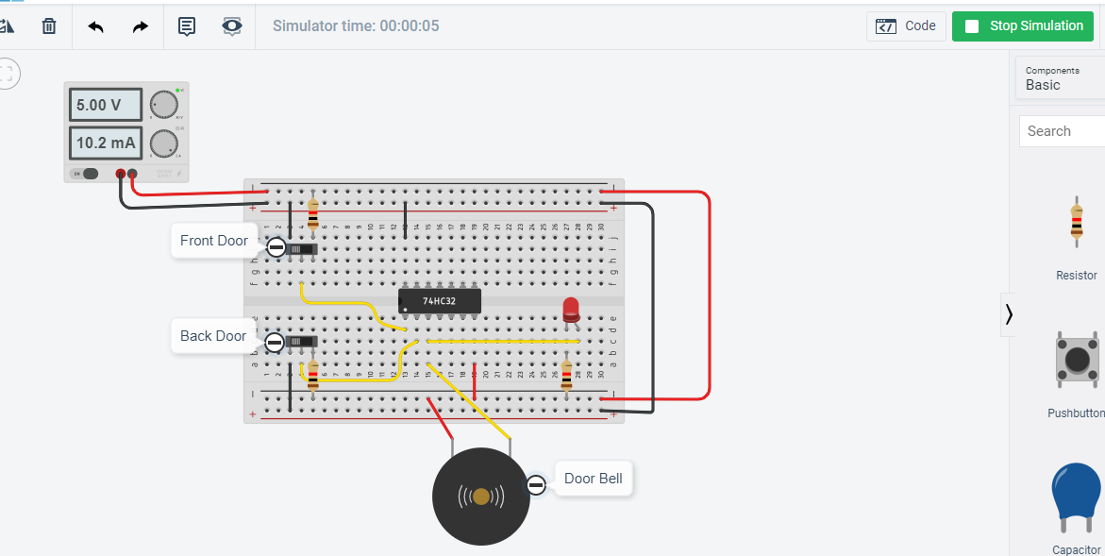

**B) Burglar Alarm(when light is not falling over the LDR.)**

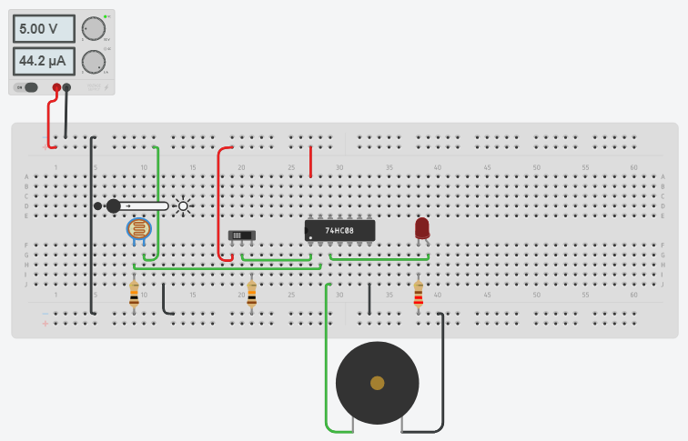

**Burglar Alarm(when light is falling over the LDR.)**

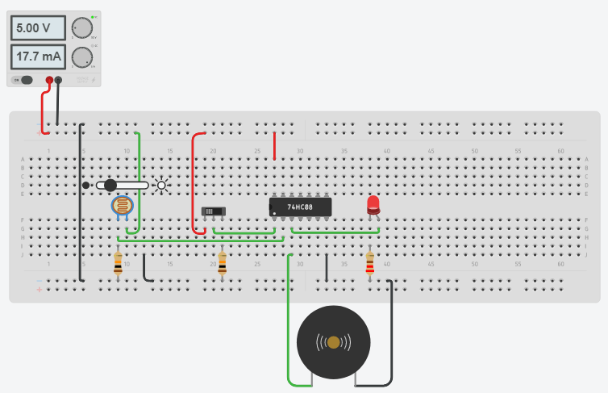

1. **Automatic fan controller (NOT) (when the temperature is 29oC)**

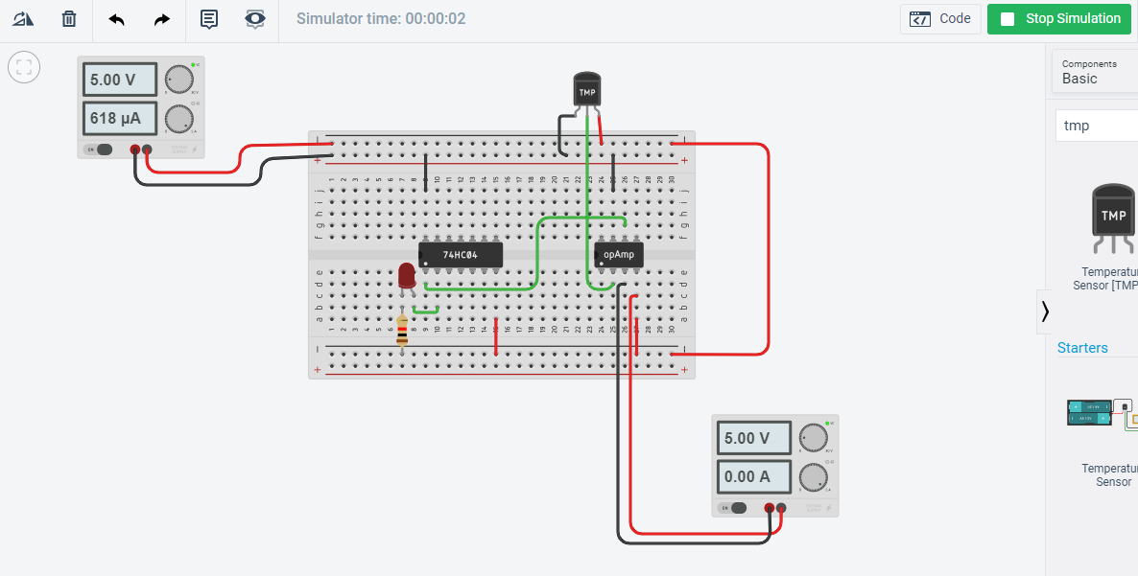

**Automatic fan controller (NOT) (when the temperature is 31oC)**

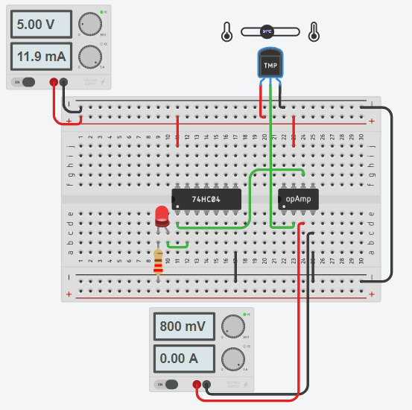

# Concept used:

**For Door Bell,** the SPST (toggle) switches are used as inputs to the OR gate, the output of the OR gate is attached to a Buzzer which will ring when any one of the switches is pressed.

**For Burglar Alarm,** the alarm switch which is a SPST (toggle) switch and the person detection is achieved by the light falling on the sensor ( because of the light source used by the burglar) made from LDR, is used.

**For an Automatic Fan Controller,** the temp sensor input needs to be given to the input terminal of any one of the NOT gate inside this IC, and the output actuator can be driven from the output terminal of the same gate**.**

# Learning/Observation:

It was observed that after the proper connection adjustments we will solve the day to day problems with simple logic gates.

# Troubleshooting:

Errors faced while doing LAB practical is as in tinkercad the default resistor’s is set to 1K ohm, while using it resistor LED does n’t glow.

So, to troubleshoot this problem, I changed the resistor to 1 ohm, after that I was getting the required current needed to turn on Led.